

Delivery & Logistic Services
Merkur Expo Logistics GmbH has been appointed the official forwarding agent and clearance agent for KENES congress We offers the following services: customs clearance, delivery to the booth, freight forwarding, manpower & trolleys for un‐loading/loading during build‐up and dismantling, storage of empty crates, transportation to and from the Exhibition Hall.
For security, insurance, and efficiency reasons Merkur is the exclusive agent nominated by the organizer for move in and move out handling of empties for the congress .
Exhibitors and booth builders are free to deliver their goods or to pick their goods up from outside the venue. Those who use their own facilities up to the venue are requested to coordinate their time schedule and unloading of their cargo into the venue with Merkur .
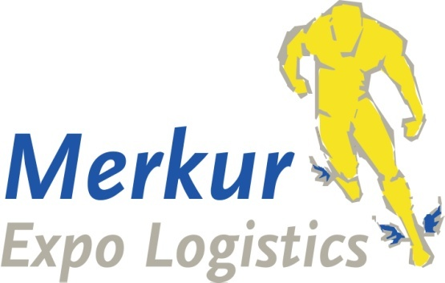
Contact Details:
Merkur Expo Logistics
Contact: Mrs Irit Sofer
Mobile: +972-52-8890129
E-mail: irit.sofer @merkur-expo.com

The UK left the EU in January 2021, and this will affect the way in which you send goods to UK events

All shipments to Edinburg are subject to customs clearance please make sure to send proforma invoice and packing list one week before sending the goods
*** Important notice: Please note that temporary and permanent import goods should be sent on separate invoices and for airfreight on separate airwaybills (HAWB x2 are OK) ***

Please note these important dates:
Buildup | November 11 10:00-20:00 Space only  15:00-20:00 all stands
Exhibition | November 12-15
Breakdown | November 15 14:00-19:00
SERVICE | DEADLINE
Door to door shipments | Please contact Merkur
Airfreight shipments | Please contact Merkur
Shipment via Germany Advance warehouse | No later than November 4th
Exhibition goods - Direct deliveries to Congress venue | Subject to pre-registration

Services, Delivery Address & Shipping Instructions
1. Door to Door Shipment
We offer companies consolidated trucking services from starting point to venue as part of consolidated international shipments for the congress. This will assist in reducing costs and ensuring timely delivery.

2. Airfreight Shipments

Please contact Merkur for instructions

IMPORTANT !!! Please do not send any airfreight shipment unless you receive very specific instructions for invoices, packing list, etc.

3. Shipment via Germany Advance Warehouse

Merkur Expo Logistics GmbH
Im Steinigen Graben 7
63571 Gelnhausen

Germany

Notify:

Congress name _________________

Name of Exhibitor ________________

Stand no. ______________________

Attention for all shipments we need a full pre-advice in advance Please send your full pre-advice to Merkur
Shipments with insufficient information’s or missing pre-advice might be delayed.

4. Congress Venue
The Edinburgh International Conference Centre in Edinburgh, Scotland

11. Heavy & Oversized Shipments

Heavy and oversized shipments apply to any single exhibit in excess of 1000 kg and 5 CBM that requires the use of a forklift mobile crane for installation.

Exhibitors with heavy and oversized exhibits must inform us at least seven days prior to delivery. A detailed layout should also be provided to better assist our onsite operations.

12. Payment terms

Terms of Payment

1. Invoices will be sent by e-mail only.

2. The invoicing is per shipment.

3. Full payment of the incoming handling charges must be received prior the delivery to the booth.

4. The outgoing handling charges are payable immediately after receipt of our invoice.

5. Payment can be made, by credit card (VISA and MASTERCARD ) or by wire transfer. Personal or foreign cheques are not acceptable.

6 .vat will be added

7. 1,5% interest per month will be charged on overdue payments

please complete and sign the attached material handling form/payment confirmation and return it to our attention.
Please note that your signature will be used as payment guarantee based on the general tariff. Any services not outlined in the attached tariff will be quoted on an individual basis.

Please notify “ Merkur” immediately about any requirements relating to invoices.
Please note that all payments are in €.

12.Terms and conditions

All orders are accepted exclusively on the basis of the local & German forwarders terms and conditions (ADSp).

We wish you a successful experience!
MERKUR EXPO LOGISTICS

