How to change the ratio of your slides

Basic Steps
To change the slide size:
- Select the Design tab on the toolbar ribbon.
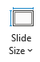
- Select Slide Size near the far-right end of the toolbar. à

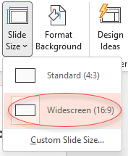
- Select Widescreen (16:9). à

